Practicum Final Exam –Even Semester Year 2020/2021
Subject |  |  | COMP6048 - Data Structures |  |  | 
Class | : | PE01 / SE01 |  | Start Date | : 14 June 2021
Lecturer | : | D4730 - Rini Wongso, S.Kom., M.T.I |  | Start Time | : 13.20
Lecturer | : |  |  | End Date | : 14 June 2021
Lecturer | : |  |  | End Time | : 15.20

PERATURAN UJIAN:
Exam Regulations:
- Mahasiswa tidak diperbolehkan berdiskusi dan/atau bekerja sama dengan peserta ujian lainnya
Student is not allowed to discuss and/or work together with other exam participants
- Mahasiswa tidak diperbolehkan untuk membuka dan menyalin dari BUKU atau CATATAN, VIDEO dari pengajar (recording kelas, VBL, Youtube, dsb) dan REFERENSI lainnya
Student isn't allowed to open and copy from any resources such as notes, videos (class recording, VBL, Youtube, etc) and other references
- Mahasiswa tidak diperbolehkan membuka dan menyalin jawaban dari internet (google, stackoverflow, dsb)
Student isn't allowed to open and copy answer from the internet (google, stackoverflow, etc)
- Asisten BERHAK memberi nilai 0 (NOL) bagi peserta ujian yang melakukan segala bentuk kecurangan
Assistant is able to give 0 (ZERO) score for exam participant who does any cheating actions
- Kumpulkan jawaban tepat pada waktunya, apabila terlambat mengumpulkan maka jawaban tidak akan dikoreksi dan nilai mahasiswa adalah 0
Submit the answer on time, if not, then the answer will not be checked, and the students will receive 0 (ZERO)
- Bila Anda tidak membaca peraturan ini, maka Anda dianggap telah membaca dan menyetujuinya
If you have missed to read these regulations, so you are considered to have read and agreed on it



SOFTWARE YANG DIGUNAKAN:
Software will be used:
- Dev-C++ 5.11

FILE YANG DIKUMPULKAN:
File must be collected:
- [NIM].CPP

PERHATIAN!
Attention!
- Bagi yang mengerjakan tidak sesuai dengan soal, maka akan diberikan nilai NOL (0)
For those who do not work in accordance with the exam case will be marked as ZERO (0)
- Bagi yang mengerjakan tidak sesuai dengan software dan versi yang telah ditetapkan, maka akan tetap dikoreksi dengan software dan versi yang telah ditetapkan
For those who do not work in accordance with the software and specific version will be corrected by the predefined software and version
- Kompres semua jawaban yang akan diunggah. Pastikan format pengumpulan nama file dan ekstensi sesuai dengan format berikut: [NIM]-[NAMA].zip
Compress all file that will be uploaded. Make sure the format for collecting file name and extension according to the following format: [NIM]-[NAME].zip

Soal
Case

DeluXe Smartphone Shop
DeluXe Smartphone Shop is an application used by the admin to manage the phone menu. This application will be developed using AVL Tree. The descriptions of the program are:
- Program consists of 4 menus:
1. Insert New Phone
2. View All Phones
3. Remove Phone
4. Exit
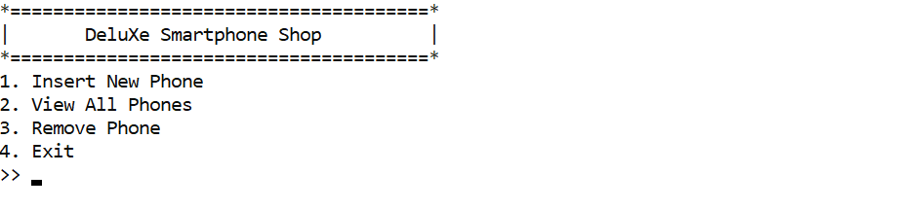
Figure 1. Main Menu
- If user chooses Insert New Phone (Menu 1):
  - Ask user to input the following data:
    - Phone Name
      - Validate that the length must be between 7 and 25 characters
      - Validate that the name must be unique
      - Validate that the name must contain 2 or more words
    - Phone Description
      - Validate that the first letter of the description must be capitalized
    - Phone Type
      - Validate that the type must be between “Premium”, “Rare”, and “Common”
    - Phone Type
      - Validate that the price must be between 1000000 and 10000000
  - After that, push all the data to AVL Tree with Phone Name as key
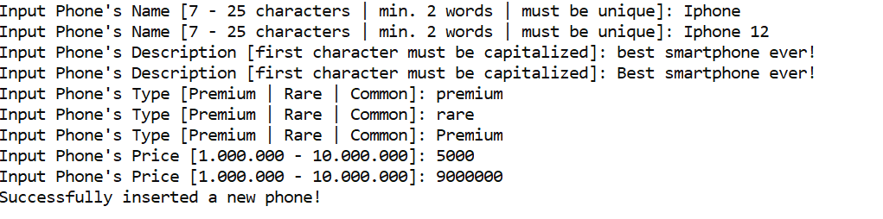
Figure 2. Insert Phone
- If user chooses View Phone (Menu 2):
  - If there is no data in the AVL, print “No phone available! please come back later...”
  - Otherwise, ask user to input view method. Validate that the inputted method must be between 1 and 3
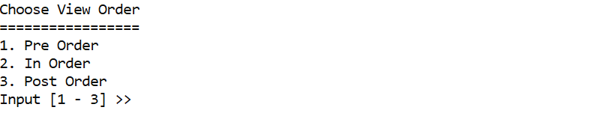
Figure 3.Choose View Method
    - If user choose “Pre Order” (Sub Menu 1), show the data using Pre-Order method
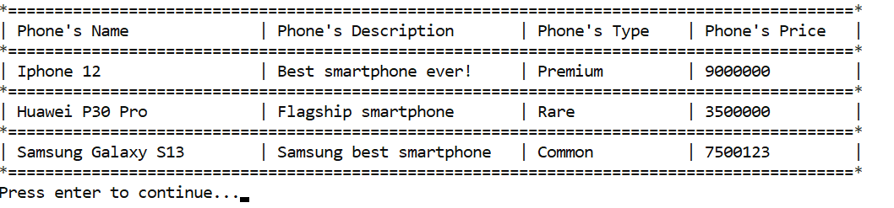
Figure 4. View Phone in Pre-Order
    - If User choose “In Order” (Sub Menu 2), show the data using In-Order method
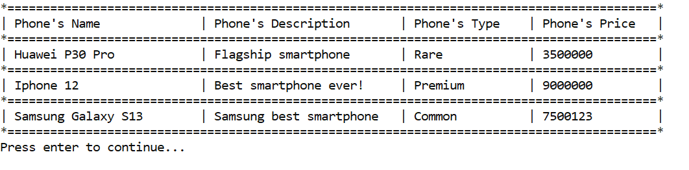
Figure 5. View Phone in In-Order
    - If User choose “Post Order” (Sub Menu 3), show the data using Post-Order method
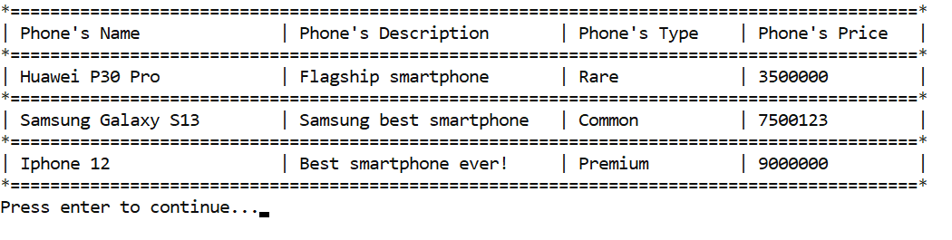
Figure 6. View Phone in Post-Order
- If user chooses Remove Phone (Menu 3):
  - If there is no data in the AVL, print “No phone available! please come back later...”
  - Otherwise, ask user to input phone name
    - Validate phone name must exist in the AVL Tree
    - If phone exists, ask user to input confirmation, validate the confirmation must be either “Yes” or “No” (case-insensitive)
    - If user chooses “Yes” then remove the phone from AVL tree
    - Otherwise, redirect user to main menu
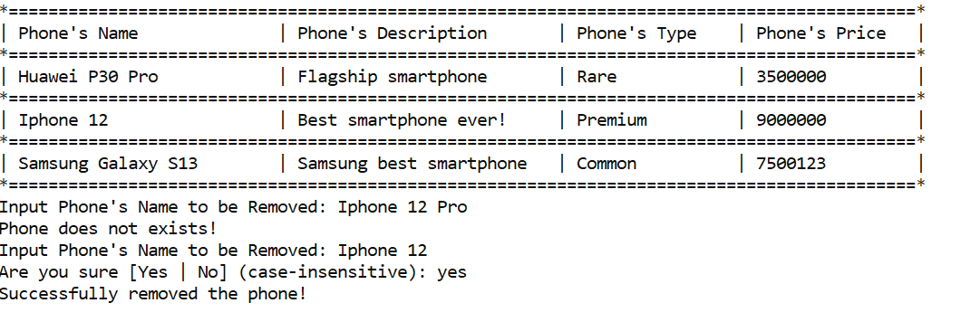
Figure 7. Remove Phone
- If user chooses Exit (Menu 4), remove all phone in the AVL and close the program

Please run the EXE file to see the sample program

